Experiment 8: Implement Boosting Technique (AdaBoost) and Analyze Performance
Aim
To implement the AdaBoost (Adaptive Boosting) classification algorithm to predict students' results based on study hours, attendance, and assignments, evaluate the model's performance, and visualize the importance of each feature.
Algorithm
- Import the required libraries: Pandas, train_test_split, AdaBoostClassifier, evaluation metrics, and Matplotlib.
- Load the dataset from the CSV file data.csv.
- Select the input features Hours_Studied, Attendance, and Assignments and store them in X.
- Select the target variable Result and store it in y.
- Split the dataset into training and testing sets using train_test_split(), with 80% for training and 20% for testing.
- Create an AdaBoost classifier using AdaBoostClassifier(n_estimators=50, random_state=42).
- Train the model using model.fit(X_train, y_train).
- Predict the results for the testing dataset using model.predict(X_test).
- Evaluate the model using accuracy_score(), confusion_matrix(), and classification_report().
- Extract the feature importance values using model.feature_importances_.
- Plot the feature importance values in a bar chart using plt.bar().
- Add axis labels and a title, and display the graph using plt.show().

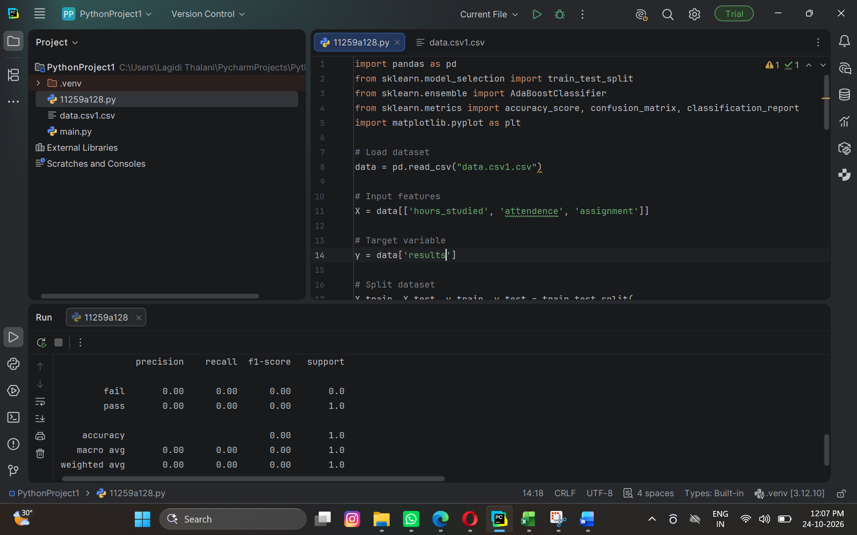

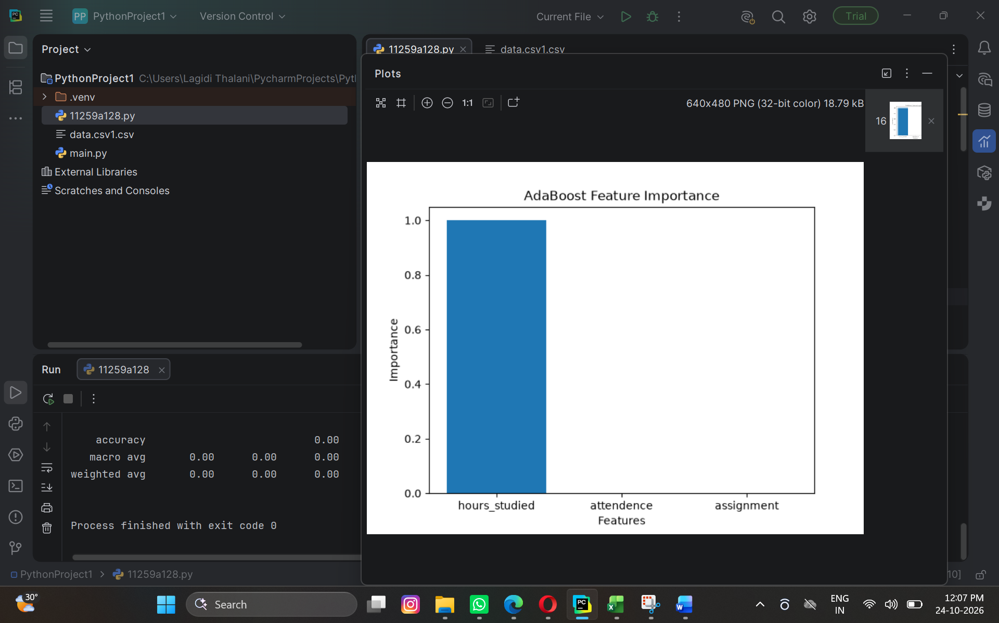

Result
The AdaBoost classification model was successfully trained and used to predict students' results. The model's performance was evaluated using the following metrics:

